Order Of Service

Singing: Psalm 145—CW page 119

Reading: Psalm 22:1-15

Opening Hymn: TLH 128

Reading: I Corinthians 15:1-11

Request Hymn: CW Supplement 749

Reading: Mark 3:7-12

Sermon Hymn: TLH 330

Sermon Text: Luke 13:6-9

One More Chance

Prayer

The Apostles’ Creed, TLH page 12

Holy Communion

The Lord's Prayer

The Blessing

Closing Hymn: TLH 135

************
Bible Study: Lambs: Grizzly Bear
Sheep: Philippians
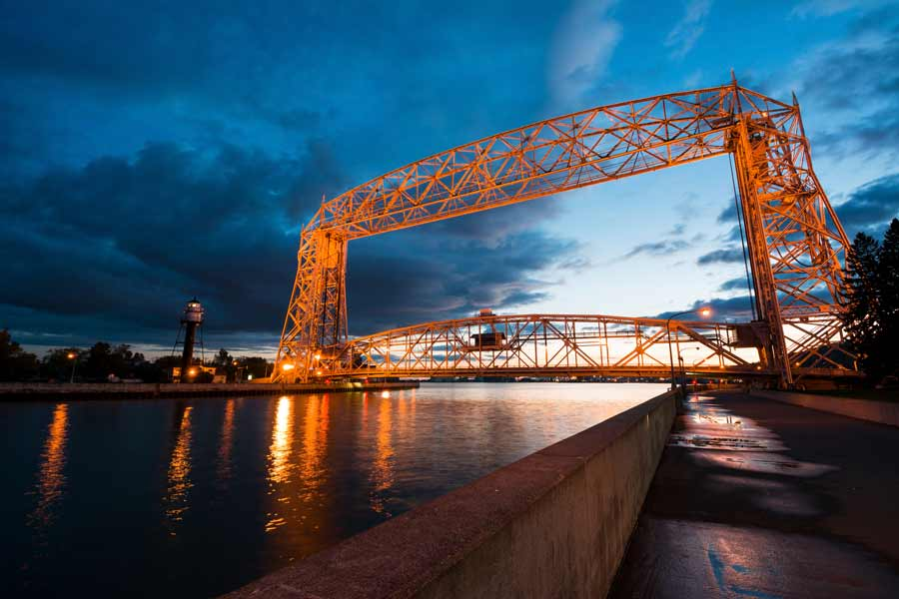

Spring On The Lake

Water
Of
Life

8 May 2022

W A T E R O F L I F E

Independent Christian Church—Conservative Lutheran Doctrine

Worship Service: 9:30 a.m.

Larry Cooper, Pastor E-Mail address:
111 N. Ridge Road lcooper@wateroflife.cc
Coon Valley, WI 54623 Web Site:
www.wateroflife.cc

* * * * * * * * * * * * * * * * * * * * * * * * * * *

Sermon Text: Luke 13:6-19

One More Chance

* * * * * * * * * * * * * * * * * * * * * * * * * * *

6 He spake also this parable; A certain man had a fig tree planted in his vineyard; and he came and sought fruit thereon, and found none.
7 Then said he unto the dresser of his vineyard, Behold, these three years I come seeking fruit on this fig tree, and find none: cut it down; why cumbereth it the ground?
8 And he answering said unto him, Lord, let it alone this year also, till I shall dig about it, and dung it:
9 And if it bear fruit, well: and if not, then after that thou shalt cut it down.

